**Tasks**

**Task1**

What Does Object-Oriented Design (OOD) Mean?

Object-oriented design (OOD) is the process of using an object-oriented methodology to design a computing system or application. This technique enables the implementation of a software solution based on the concepts of objects.

The OOD process takes the conceptual systems model, use cases, system relational model, user interface (UI) and other analysis data as input from the OOA phase. This is used in OOD to identify, define and design systems classes and objects, as well as their relationship, interface and implementation.

**Task2**

What are the components of the core of operating system?

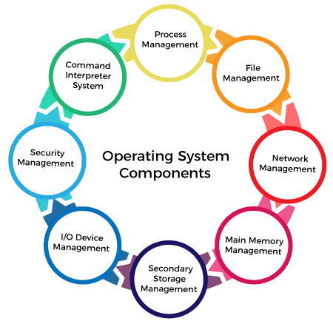

Process Management

The process management component is a procedure for managing many processes running simultaneously on the operating system. Every running software application program has one or more processes associated with them.

For example, when you use a search engine like Chrome, there is a process running for that browser program.

Process management keeps processes running efficiently. It also uses memory allocated to them and shutting them down when needed.

### File Management

A file is a set of related information defined by its creator. It commonly represents programs (both source and object forms) and data. Data files can be alphabetic, numeric, or alphanumeric.

### Network Management

Network management is the process of administering and managing computer networks. It includes performance management, provisioning of networks, fault analysis, and maintaining the quality of service.

### Main Memory management

Main memory is a large array of storage or bytes, which has an address. The memory management process is conducted by using a sequence of reads or writes of specific memory addresses.

It should be mapped to absolute addresses and loaded inside the memory to execute a program. The selection of a memory management method depends on several factors.

### Secondary-Storage Management

The most important task of a computer system is to execute programs. These programs help you to access the data from the main memory during execution. This memory of the computer is very small to store all data and programs permanently. The computer system offers secondary storage to back up the main memory.

### I/O Device Management

One of the important use of an operating system that helps to hide the variations of specific hardware devices from the user.

### Security Management

The various processes in an operating system need to be secured from other activities. Therefore, various mechanisms can ensure those processes that want to operate files, memory CPU, and other hardware resources should have proper authorization from the operating system.

Security refers to a mechanism for controlling the access of programs, processes, or users to the resources defined by computer controls to be imposed, together with some means of enforcement.

### Command Interpreter System

One of the most important components of an operating system is its command interpreter. The command interpreter is the primary interface between the user and the rest of the system.

Many commands are given to the operating system by control statements. A program that reads and interprets control statements is automatically executed when a new job is started in a batch system or a user logs in to a time-shared system. This program is variously called.

* The control card interpreter,
* The command-line interpreter,
* The shell (in UNIX), and so on.

**Task3**

**1883:** The first programming language was developed in 1883 when [Ada Lovelace](https://www.sdsc.edu/ScienceWomen/lovelace.html) and Charles Babbage worked together on the Analytical Engine, which was a primitive mechanical computer. Lovelace was able to discern the importance of numbers, realizing that they could represent more than just numerical values of things. Lovelace wrote an algorithm for the Analytical Engine, the first computer program, to compute Bernoulli numbers.

**1949: assembly language**

**1952**:autocode

**1957:fortran**

**1958**: Algol was created as an algorithmic language. It was also a precursor to programming languages such as Java and C.

**1959: cobol** was created by Dr. Grace Murray Hopper to be a language that could operate on all types of computers.

**1964**: John G. Kemeny and Thomas E. Kurtz developed [BASIC](https://www.uopeople.edu/blog/6-reasons-why-you-should-learn-basic-programming/) for students without a strong background in technology and math, enabling them to still use computers.

**1970**: Niklaus Wirth developed pascal, naming it after Blaise Pascal. This language is easy to learn and was the main language used by Apple for early software development.

**1972**: Dennis Ritchie developed C, generally regarded as the first high-level programming language. This means that it's closer to human language and less like machine code.

**1978**: Cleve Moler developed MATLAB for writing math programs. This language is used for research and education.

**1983**: Brad Cox and Tom Love created Objective-C as the main language used for writing Apple software.

**1983**: Bjarne Stroustrup created C++, which is an extension of the C programming language. This is one of the most used languages in the world.

**Task4**

What are the type of languages that we could use in giving instructions?

**Javascript**

**Php**

**Python**

**Ruby**

**Groovy**

**Perl**

**Lua**

**Bash**

**Powershell**

**R**

**Task 5**

The Peregrine programming language - A Python-like language that's as fast as C.

**Task 6**

**Open source not open source**

1.JavaScript VBscript,

|  |  |
| --- | --- |
| 2.Python | c# |
| 3.PHP | matlab |
| 4.Swift | microfocus cobol |
| 5.R Programming | ibm mainframe |
| 6.C++ | AIX |
| 7.Go | linux compilers |

8.Kotlin 9.Scala

10.Ruby

**Task7**

**Advantages of javascript**

**-speed**

**-simplicity**

**-popularity**

**-interoperabillity**

**-server load**

**-rich interfaces**

**-versatility**

**-less overhead**

**Task8**

Fragmentation is an unwanted problem in the operating system in which the processes are loaded and unloaded from memory, and free memory space is fragmented. Processes can't be assigned to memory blocks due to their small size, and the memory blocks stay unused. It is also necessary to understand that as programs are loaded and deleted from memory, they generate free space or a hole in the memory. These small blocks cannot be allotted to new arriving processes, resulting in inefficient memory use.

The conditions of fragmentation depend on the memory allocation system. As the process is loaded and unloaded from memory, these areas are fragmented into small pieces of memory that cannot be allocated to incoming processes. It is called **fragmentation**.